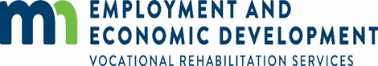

***What is Vocational Rehabilitation services (VRS) Transition Services?***

**VRS is an employment services program for students and young adults with disabilities (Age 14-22 years old). In Minnesota, every high school has a Vocational Rehabilitation (VR) counselor who can help students with disabilities to gain skills, find a job, and start a career.**

***How can vrs assist students while in high school?***

A VR counselor can prepare students for after high school graduation with the following services:

* Exploring career options through job shadows, informational interviews, labor market information, and other resources
* Gain work experiences
* Identify post-secondary education and training options
* Job seeking skills training
* Understand interests and talents in relation to employment opportunities
* Learning about disability and its impact
* Provide opportunities to practice communication and interpersonal skills for work.
* Financial literacy and benefits planning

**CONTACT INFORMATION**

**Careerforce – Vocational Rehabilitation Services**

**400 South State Street, Suite 180 Fairmont, MN 56031**

**Phone: (507) 235-5518**

**www.careerforcemn.com/fairmont**

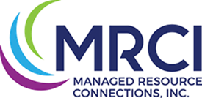

***“Creating innovative and genuine opportunities for people with disabilities or disadvantages at home, at work and in the community.”***

***SERVICES FOR INDIVIDUALS***

* Employment services
* Day services
* Family services
* Transitional services (Youth aged 14-22 years old)
* Employees to fit your employment needs.
* Consultants to help with Individual Employment Placement.
* Long- and short-term employment.
* Supports/Job Coaching as needed for success in individual employment.
* Training as needed for specific jobs.

***BRIDGE TO THE FUTURE***

MRCI’s Bridge to the Future summer training program will provide participants with the tools they need for a successful transition into the world of work.

**The four-week sessions will provide training in job search/retention techniques while building participants’ self-confidence and accountability.**

The program offers a stimulating curriculum as well as a solid, practical introduction of the skills needed to achieve successful employment. Outside of the classroom, the program provides hands-on training with area business partners

**CONTACT INFORMATION**

**MRCI – Fairmont**

**701 Cory Lane, Fairmont MN 56031**

**Phone: (507) 238-4388**

**www.mymrci.org/fairmont.html**

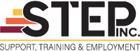

***WHO WE ARE***

A ***STEP*** To Employment is a division of STEP Inc. which was formed to focus primarily on individual employment. We give individuals the support they need to complete in the workforce and meet the standards set by employers.

* Paid work experience to develop good work habits employer expect
* Work readiness training to learn how to write resumes, cover letters, apply for jobs, and write follow-up and thank you notes
* Interest and skill assessments to find out what you’re good at, what you enjoy, and how careers for those skills/interests
* Explore options for after high school/GED like full time jobs, short term training, apprenticeships, and college
* Career planning focused on in demand occupations
* Scholarships for eligible educational/advanced training programs

***WHAT WE OFFER***

***WHO WE SERVE***

We have well-trained employment consultants to help serve you. “A ***STEP*** To Employment” is driven with the philosophy that everyone has skills to contribute to the workforce and are employable.

**We provide services in:**

Martin, Faribault, and Watonwan Counties. We will also provide services in other surrounding counties upon request.

***OUR EMPLOYEES***

* Meet income guidelines and additional eligibility guideline (details on application)
* Are eligible to work in the United States
* Want to complete educational or employment goals
* Live in the 9-county service area (Blue Earth County, Brown County, Faribault County, Le Seuer County, Martin County, Nicollet County, Sibley County, Waseca County)

**CONTACT INFORMATION**

**STEP INC.**

**5 Downtown Plaza, Fairmont, MN 56031**

**Phone: (507) 238-4341**

**www.stepinc.org**

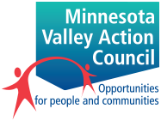

***YOUNG ADULT CAREER DEVELOPMENT PROGRAM***

Minnesota Valley Action Council (MVAC) serves Young Adults ages 16-24 to help the achieve educational and training goals. We do this through:

MVAC serves Young Adults ages 16-24 who:

**CONTACT INFORMATION**

**Minnesota Valley Action Council (MVAC)**

**MVAC - Martin County MVAC - Faribault County**

**Phone: (507) 235-5518 Phone: (507) 526-5291**

**www.mnvac.org**

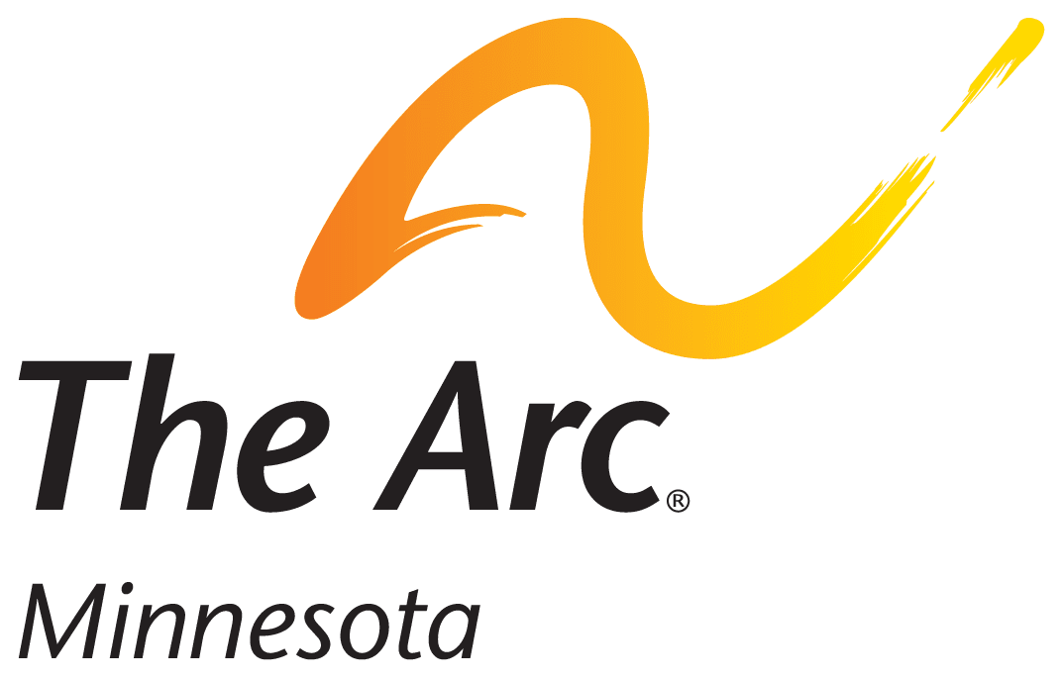

***Southwest Region - Who We Are***

The Southwest Region provides programs and services to people with intellectual developmental disabilities and their families in Blue Earth, Brown, Cottonwood, Faribault, Jackson, Le Sueur, Lincoln, Lyon, Martin, Murray, Nicollet, Nobles, Pipestone, Redwood, Rock, Waseca, Watonwan, and Yellow Medicine counties.

***Ways We Can Help***

***People First***

* Friends and Family Support Groups
* Self-Advocacy Options: Aktion Theatre Club Group; Different Drummer Dance Clubs; People First groups; United We Stand Players
* Housing Access Services

***GOALS FOR TRANSITION TO COMMUNITY SERVICES***

People First members of both Martin and Faribault counties work on advocacy issues, activities in the community, fundraising, and they engage in volunteer opportunities. Some local group activities have included educational sessions to review the rights all people have, and group projects, like asking the local city council for better transportation for people with disabilities.

* To assist young adults with disabilities in the transition from high school to independent living and adult life.
* To assist young adults in learning independent living skills for maximum community integration and participation.
* To provide driver permit test preparation.
* To ensure that young adults with disabilities and their families are aware of available resources and options that assist in the transition process.
* Participate in monthly meetings and activities including karaoke, meals, bowling, softball, and dances.
* Anyone is welcome to attend either or both groups/activities!
* Go to our website [**www.arcminnesota.org/events**](http://www.arcminnesota.org/events/) to view events and further contact information.

**CONTACT INFORMATION**

**The Arc – Southwest Region, Fairmont Office**

**PO Box 674, Fairmont, MN 56031**

**Phone: (507) 235-2680**



*SMILES Center for Independent Living is a nonprofit organization committed to providing a wide array of services that assist individuals with disabilities* and *that live independently, pursue meaningful goals, and enjoy the same opportunities and choices as all persons.*

* Child Care
* Disability Services
* Employment
* Health Services
* Food & Nutrition
* Thrift Stores
* Youth Organizations

***TRANSITION TO COMMUNITY SERVICES***

The transition from school to community is significant for every young person with a disability. Our transition program provides a bridge between the security of school and the opportunities and responsibilities of adult life.

**Small group independent living skills training sessions are provided within the school and community. This program is available to students with disabilities between the ages of 14 and 22.**

**CONTACT INFORMATION**

**SMILES – Fairmont Office**

**301 Downtown Plaza, Suite 3, Fairmont, MN 56031**

**Phone: (507) 235-3488**

**www.smilescil.org**

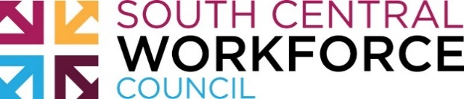

**Faribault and Martin Counties Youth Directory**

This directory will help you find information about:

* Counseling
* Education
* Libraries
* Recreation
* Housing Programs
* Transportation
* Youth Services

Scan this QR code with your smartphone

to link to the youth directory online.



**This directory is also available online at:**

**www.workforcecouncil.org/youth-council/projects/youth-directories/**

*This directory was developed by a subcommittee of the South Central Youth Council.*

MARTIN AND FARIBAULT COUNTY TRANSITION PROGRAMS AND RESOURCES FOR YOUTH WITH DISABILITIES

In collaboration with the Martin and Faribault County Community Transition Inter-Agency Committee (CTIC)

